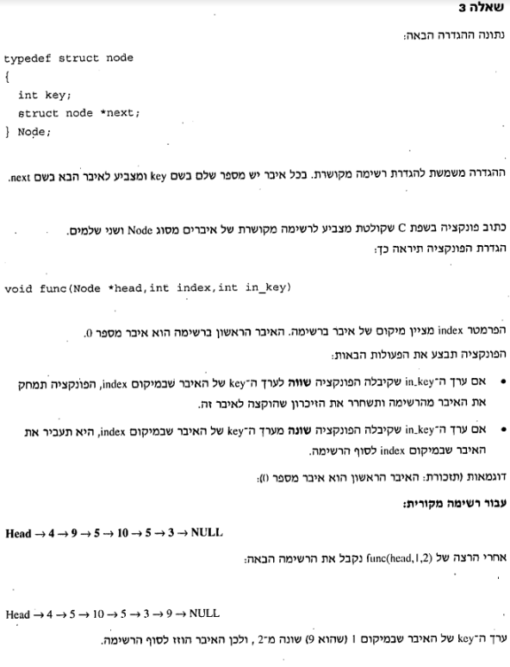

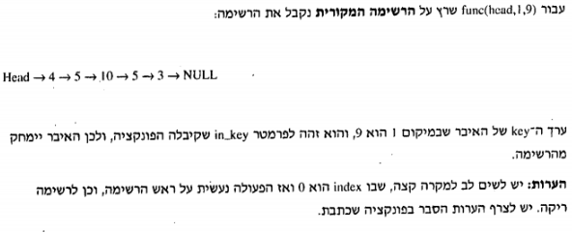

void func(Item \*list, int data, int index)

{

Item \*temp, \*x;

temp = list;

x = NULL;

int cnt = 0, num;

while (temp->next != NULL)

{

cnt++;

if (temp->key == data && cnt == index)

if (x == NULL)

{

list = temp->next;

free(temp);

return;

}

else

{

x->next = temp->next;

free(temp);

printf("The Item %d is deleted !!!\n", data);

return;

}

if (temp->key == data)

if (x == NULL)

{

list = temp->next;

num = data;

temp = Add(temp, num);

free(temp);

return;

}

else

{

x->next = temp->next;

num = data;

temp = Add(temp, num);

free(temp);

return;

}

x = temp;

temp = temp->next;

}

printf("No such entry (%d)to delete !!!\n", data);

}